

Sri Lanka Institute of Information Technology

# B.Sc. Honours Degree/Diploma Information Technology

in

Final Examination

Year 2, Semester 1 (2019)

# IT2040 - Database Management Systems

Duration: 2 Hours

## June 2019

Instructions to Candidates:

* This paper is preceded by 10 minutes reading period. The supervisor will indicate when answering may commence.
* This paper has 4 questions. Answer all questions.
* Write answers in the booklet given.
* Total marks 100.
* This paper contains 4 pages including the cover page.
* Electronic devices capable of storing and retrieving text, including calculators and mobile phones are not allowed.

### Question 1 (20 marks)

Convert the following EER model in to the relational model. Indicate the primary keys and the foreign keys of the resulted relations clearly.

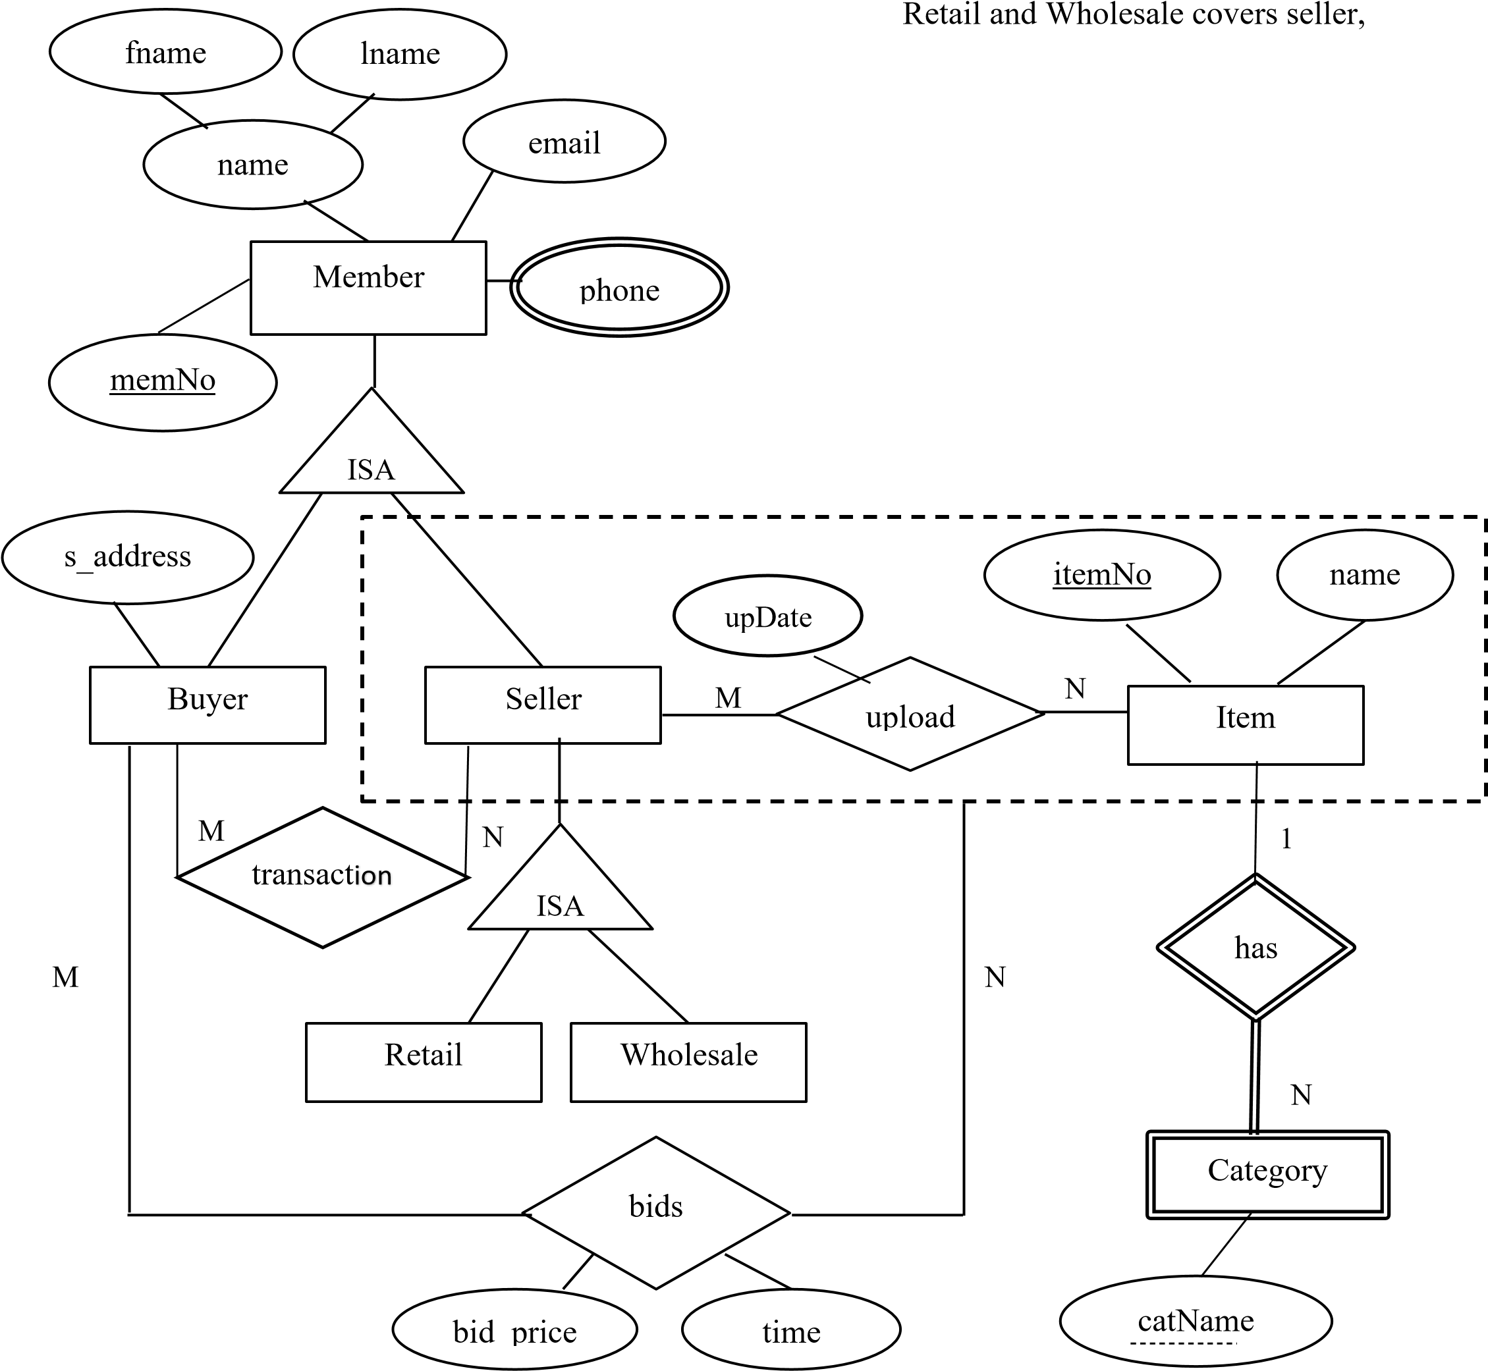 Buyer overlaps Seller

member(memNo, fname, lname, email)  
buyer(memNo, s_address)  
 Foreign Key buyer(memNo) references member (memNo)  
seller(memNo)  
 Foreign Key seller(memNo) references member (memNo)  
retail(memNo)  
 Foreign Key retail(memNo) references member(memNo)  
wholesale(memNo)  
 Foreign Key wholesale(memNo) references member(memNo)  
phoneNo(memNo, phone)  
 Foreign Key phoneNo(memNo) references memNo(memNo)  
transaction(buyerID, sellerID)  
 Foreign Key transaction(buyerID) references buyer(memNo)  
 Foreign Key transaction(sellerID) references Seller(memNo)  
Item(itemNo,name)  
category(cartname, itemNo)  
 Foreign Key category(cartname) references item(itemNo)  
upload(memNo, itemNo)  
 Foreign Key upload (memNo) references  
 Foreign Key upload (itemNo) references item (itemNo)   
bids(memNo,itemNo,buyerID,bid_price, time)  
 Foreign Key bids(memNo) references seller(memNo)

### Question 2 (15 marks)

Consider a relation **R (A, B, C, D, E, F)** with the following set of functional dependencies over **R**:

**F = {A** → **BEF, B** → **E, C** → **D, AC** → **B}**

1. Find all the keys that follow from the given FDs using attribute closure, showing how you obtained them. (6 marks)

A->BEF

AC🡪ABC

AC 🡪 ABCEF

AC 🡪 ABCDEF

1. Is **R** in 3NF? Give reasons for your conclusion. (3 marks)

R is not in 3NF

1. Is **R** in BCNF? Give reasons for your conclusion. If R is not in BCNF, convert it to a set of

BCNF relations. (6 marks)   
R is not in BCNF

### Question 3 (25 marks)

Consider the database of a printing company, which prints books according to the requests of authors with the following schema:

Book (bookID, title, publisher, publishedYear)

Author (AuthorID, firstname, lastname)

WrittenBy (AuthorID, bookID, authorPosition)

Publisher (publisher, country,city)

**Book** table stores the book ID, title, publisher of each book and the year the book is published. **Author** table stores the author ID, first name and last name of all authors. **WrittenBy** table stores the author ID of the author, book ID of the book and the position of the author (such as first author, second author) for each book written.

**Publisher** table stores the name of the publisher and country and the city the book is published.

Write **relational algebra** statements to answer the following queries

1. Display the titles of the books printed in 2019. (2 marks)

Select title   
from book  
Where publishedYear = 2019

1. Display the titles of the books published in New York city. (4 marks)   
   select title  
   from book b, publisher p  
   where b.publisher = p.publisher and  
    city = “New York”
2. Display the name of the publisher who published both ‘Fundamentals of Database systems’ and Database Applications’ in America. (5 marks)   
   select publisher  
   from publisher p, book b  
   where b.publisher = p.publisher and  
    b.title = ” Fundamentals of Database systems”, “Database Applications”
3. Display the first name and last name of authors who are only first authors. (5 marks)   
   select a.firstname, a.lastname  
   from author a, writtenBy w  
   where a.authorID = w.authorID and  
    w.authorPosition = 1
4. Display the titles of books with most number of authors. (9 marks)   
   select b.title   
   from book b, writtenBy w  
   where b.bookID = w.bookID  
   group by bookID  
   having max(count(w.bookID))

### Question 4 (40 Marks)

Consider the following relations in a database created for a university.

Module (mCode: char(6) , mName: varchar (50), credits: int, specialization : char(4), year: int, semester: int)

Student (sId: char(10), sName: varchar(50), age: int, gpa: int, address: varchar(50))

Follow (sId: char(10), mCode: char(6), semester: int, academicYear: int, grade: char(1))

Class (cId: int, mCode: char(6), sId: Char(10), type: varchar(10), day: char(3), time:time, len: int, hId: char(4))

Hall (hId: char(4), building: varchar(15), floorNo: int, capacity: int)

**Module** relation stores the code (*mCode*), name (*mName*), number of credits (*credits*) and the *specialization* the module belongs to (such as ‘IT’, ‘SE’, ‘CSN’), *year* and the *semester* the module is offered for each module offered. **Student** relation stores the ID (*sId*), name(*sName*), *age*, cumulative gpa (*gpa*) and *address* of all students. For each student following a module in the university the **Follow** relation stores the ID of the student (*sId*), code of the module (*mCode*), the *semester* the module is offered (such as 1 and 2), the *academic year* the student has followed the module (such as 2018 and 2019) and the *grade* he received for the module. The **Class** relation stores the id(*cId*) , code(*mCode*) , *type* of the class (such as ‘lecture’ and ‘tutorial’), *day* the class is conducted such as (‘Mon’, ‘Tue’, ‘Wed’), start time of the class (t*ime*), length of the class in hours (*len*) and the id of the hall the class is conducted (*hId*) for each Class. **Hall** relation stores the ID (*hId*), name of the *building* the hall is in, floor number the hall is in (*floorNo*) and *capacity* of each Hall.

1. Use SQL queries to answer following questions.

i. Display the module codes and name of all modules followed by students in year 3 of ‘SE’ specialization in academic year 2018. (5 marks)

select m.mCode,m.mName

from m.module,f.follow

where m.mCode=f.mCode and m.year=3 and f.academic year=2018 and m.specialization

ii. Display the hall id and the floor number of halls which are vacant on Monday in Engineering Building. (6 marks)

Module (mCode: char(6) , mName: varchar (50), credits: int, specialization : char(4), year: int, semester: int)

Student (sId: char(10), sName: varchar(50), age: int, gpa: int, address: varchar(50))

Follow (sId: char(10), mCode: char(6), semester: int, academicYear: int, grade: char(1))

Class (cId: int, mCode: char(6), sId: Char(10), type: varchar(10), day: char(3), time:time, len: int, hId: char(4))

Hall (hId: char(4), building: varchar(15), floorNo: int, capacity: int)

Select h.hallid,h.floorno

From Hall h,class s

Where h.halliid=c.hallid and c.v.date=”vacant” and

1. Create a view named *ClassDetails* that contains class id, module name, year the module is offered, specialization, type of class and the size of the class for each class. (size of the class is the number of students following the class). (8 marks)

1. Create a function which named *getAvialability* which takes class id and module code as inputs and returns the number of more students that could be added to the class based on class size and the

capacity of the hall. (9 marks)

1. Create a trigger to ensure that for a class, students are not allocated than the capacity of the hall allocated for the class. (*Hint: Use the function created in c)*). (12 marks)